Religious vs. Secular Parenting

Introduction

If there is one thing that is taken for granted it is that in order to raise moral children of good character, that it is absolutely necessary to be obedient to God’s will and teachings through scripture. This position has basically been unchallenged for centuries as true until recent research has raised serious questions. In fact, the data show that the opposite may be true much of the time. This paper will explore the issues of religious parenting content and methods against what science currently understands about healthy and moral human development.

First, the general research findings of the impact of secular versus religious upbringing. According to a 2010 Duke University study, secularly raised kids display less susceptibility to racism and peer pressure, and are “less vengeful, less nationalistic, less militaristic, less authoritarian, and more tolerant, on average, than religious adults” (from Raising Children Without Religion May Be A Better Alternative, Suggests New Research). Children from religious families are less kind and more punitive than those from non-religious households, according to another new study described in the Guardian.

The cornerstone value for enabling caring and human rights, I would think, is empathy and those negative traits just listed work to directly undermine it. Another study states the benefits of secular parenting as: “rational problem solving, personal autonomy, independence of thought, avoidance of corporal punishment, a spirit of ‘questioning everything’ and, far above all, empathy.”

“Secular” is an umbrella term for those who do not find meaning in traditional organized religion and can be agnostics, atheists, freethinkers, or rationalists.

Secular parenting can be defined as:

An approach to parenting based on the best practices of psychological research and makes the assumption that a child is an autonomous being in development, and therefore, must be exposed to a wide range of philosophies so they can decide what resonates with their own heart and mind, while still providing values, standards, and boundaries in a loving relationship that stresses teaching over discipline that will result in a self-regulating, compassionate, moral, rational, and open-minded human being who understands themselves, the world, and can find their place in it.

Now to a discussion of the issues with religious parenting, as it is typically applied. To keep the piece to a reasonable length only the Christian religion will be referenced, and even within Christianity there are many variations from fundamentalist to the progressive wing that will have their differences. You may also see parallels in other religions. When I make comparisons with secular children, I am assuming that they are being raised in accordance with best practices. Anyone with any belief system can fail at parenting.

View of Human Nature

Many religions view man as a flawed creature in need of salvation, that is, needs to be saved. Other’s think man is basically good, but prone to excessive pleasure and other deviations from the righteous path. Genesis 8:21 states: “for the imagination of man’s heart is evil and wicked from his youth.” "The heart is more deceitful than all else and is desperately sick; who can understand it?” says Jeremiah 17:9. “Behold, I was brought forth in iniquity [evil or wicked], and in sin my mother conceived me” from Psalms 51:5. Some frequent descriptors of human nature are: sinful, weak, a wretch, lost, a worm, sheep, and totally depraved.

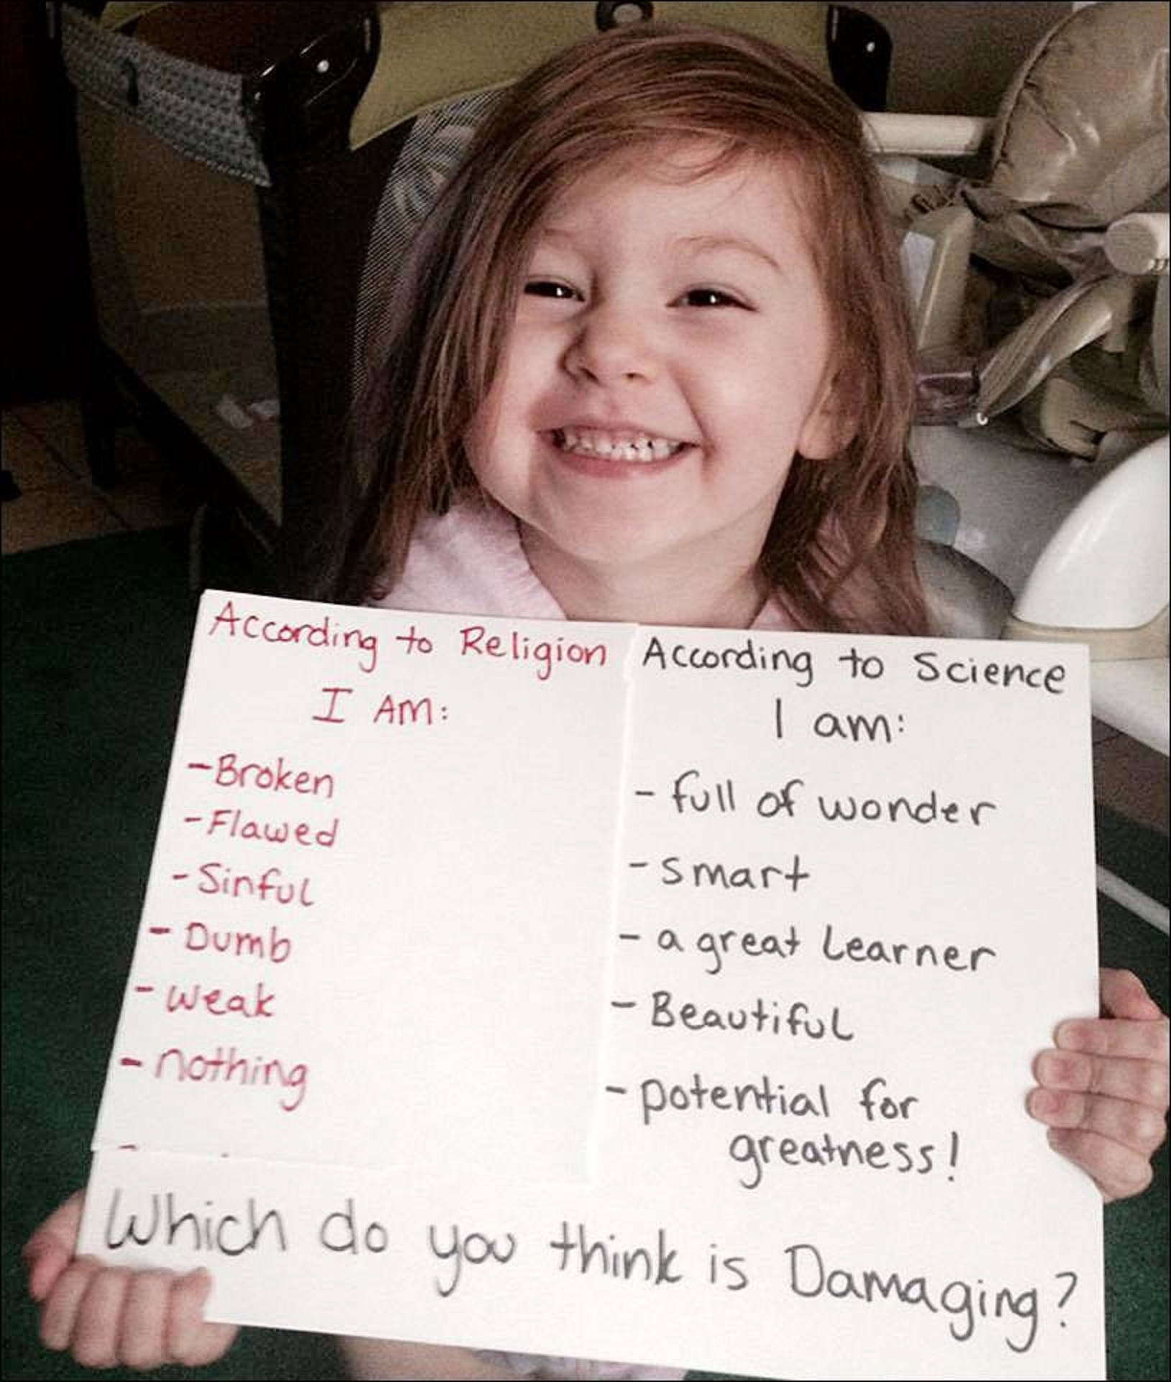

The imagery is not wholesome and who is the supposed designer of human nature?

Self-fulfilling prophecies can be operative here. If I am told that I am ‘damaged goods’ by the authority figure that I trust, how else should I feel about myself?

On the other hand, a secular viewpoint takes a more realistic posture in that we are basically good but because of more primitive tendencies we can be more selfish and less controlled emotionally. We are not basically (sinfully) lustful but have hormones to deal with. Repression of “bad” urges, feelings and sex is what is done in practice, but whatever we repress becomes a silent part of us that we sooner or later must deal with.

Religion has made sex a necessary evil (no children without sex). Catholics will earn eternal damnation for a few minutes of sexual pleasure—masturbation--the same punishment as if you are a mass murderer. St. Paul on sex (1 Cor. 7:1-4): “Now concerning the matters about which you wrote: It is good for a man not to have sexual relations with a woman. But since sexual immorality is occurring, each man should have sexual relations with his own wife, and each woman with her own husband….The wife does not have authority over her own body, but the husband.” Clearly, immorality it anything that displeases God. For some reason, St. Pauls’ hang-ups about sex have become church theology. For a deeper discussion on this from a psychologist see: A psychoanalytical study of St. Paul's theology of sex.

We are not “broken,” rather we are human.

Religion also teaches that we are special creatures inserted to the world after everything else was in place, that is, we are not part of the animal kingdom. This flies in the face of scientific evidence that we are indeed higher-order animals, especially at the genetic level where we share over 98% of the genes of other primates. Religious upbringing often teaches children to disregard science when it comes into conflict with scripture. Should children believe what 2,000 year old uneducated writers thought about the world or what science teaches us today? This is where the battle for truth begins and will be explored in more depth in another section.

What does God think is moral?

The popular argument goes, that if one does not believe in God, it is impossible for them to know right from wrong—or—even to be good. That would be alright if all Gods had the same rules and while there is overlap, faith does not automatically clarify what is right or wrong. Review the following and it will become apparent that different gods encourage different types of behavior.

- When does He want us to worship: Fridays, Saturdays, or Sundays?
- Does He allow us to eat pork?
- Are we saved by belief or good works?
- Can we drink alcohol?
- Is corporal punishment recommended?
- Are we allowed to dance, drink Coke, play cards, or wear make-up?
- Gambling?
- Contraception?
- Death penalty?
- Homosexuality?
- Can we divorce and remarry?

So we now have what believers abhor: (deity-induced) moral relativism. Where are the absolutes? Outside of some very basic values that help us survive as a group there may not be absolutes, especially when facing moral dilemmas that have no obvious or simple solution. The good news is that some basic moral values are programmed into us at birth as has been established in the Yale infant cognition studies. Conscience is not God whispering in your ear, it is neural programming. This can be proven as certain accidents affecting the brain can cause people to lose the ability to tell right from wrong or lower their inhibitions and increase aggression.

Another problem surfaces with the following logical questions: Is something good because God tells us it is? …OR…Is it good regardless of God’s commandments? If you agree with the former, then morality is arbitrary (dependent on God’s whims). If you agree with the latter, then religion is irrelevant. Further, how did man know good and evil before scripture was created?

What about things which God does not comment on like animal cruelty? How do we determine right and wrong with actions not addressed in scripture? One may answer that we are led by the Holy Spirit, which again does not solve anything as we now have over 33,000 sects or denominations of Christianity that are all supposedly guided by the same Holy Spirit. Truth is different for each sect so again we can have moral and doctrinal relativism.

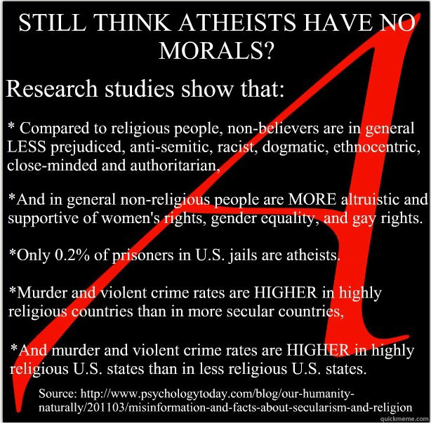

Rule-based System

Religious moral values are often codified as in the Ten Commandments. These rules have a do’s-and-don’ts format. A particular activity is either right or wrong regardless of the circumstances. Drinking is wrong, Carnival is wrong, homosexuality is wrong, pre-marital sex is wrong. Rules do not involve reasoning or reflection. God has spoken and that’s it. It has the same underlying problem as the previous section in terms of comprehensiveness. As society evolves different issues surface that are not addressed in scripture in which long debates ensue about “what would Jesus do?” which is anyone’s guess.

Do you also notice that there is no explanation behind the rules (edicts). The tacit message is to not challenge the authority figure. Religious parents reinforce this with authoritative statements like: “because I say so!” This creates moral weaklings who cannot engage in moral reasoning.

Secular morality operates in a more realistic mode by shifting the focus from rules to responsibilities. If you are going to drink then drink responsibly. Same for Carnival. If engaging in pre-marital sex it must also be done responsibly by considering the negative consequences. Responsible pre-marital sex means not catching or spreading a disease or getting pregnant, and not cheating on your partner, or phrased positively, to safely express your love to a partner.

The reasons behind the rules (younger kids) and responsibilities (adolescents) need to be discussed so that they are both understood and can be applied correctly. Knowing why you are doing something makes all the difference in both understanding and motivation to do the right thing.

Focus on Obedience and Control

Obedience is often thought of as a sign of a child that is adhering to the rules and is generally sought after in religious parenting. Unfortunately, it often becomes an end instead of a means. It also begs the question, ‘obedient’ to what? The answer is usually an authority figure. Combine these two facts and you have a child who is obedient first to their parents, then their teachers, God, their husband, and other powerful people in society. The trouble is that obedience, while necessary in young children, is not the ultimate focus of successful parenting.

What parents (and society) really should want is a self-regulating child—one who is good whenever authority figures are not around. Authority figures attempt to control rather than educate a child. Control comes from physical discipline, fear, guilt, and shame—all negative approaches. We control animals, but teach children.

Physical discipline is founded in Proverbs 13:24, which is the ‘spare the rod and spoil the child’ verse. The latest research on corporal punishment reveals that it does not work plus produces a range of negative outcomes. If your objective is to stop a child’s immediate bad behavior, it will do that but at a terrible price. It increases the amount of aggressiveness in a child because he or she is learning the wrong thing: they are not learning to be good--but instead--learning that violence can be used to solve problems. If parents can be violent they are sending the signal or modeling that violent behavior is OK.

Hitting a child does not improve trust in the parent-child relationship but instead causes resentment. A TIME magazine article goes on to state: “Children who are spanked may feel depressed and devalued, and their sense of self-worth can suffer. Harsh punishments can wind up backfiring because they can foster lying in children who are desperate to avoid being spanked. Later in life, physical punishment is linked to mental-health problems including depression, anxiety and drug and alcohol use. There’s neuroimaging evidence that physical punishment may alter parts of the brain involved in performance on IQ tests and up the likelihood of substance abuse. And there’s also early data that spanking could affect areas of the brain involved in emotion and stress regulation.”

Often, when I tell others that corporal punishment does not work, they say that their parents hit them and that is why they turned out OK. I think it is more likely they turned out OK in spite of—not because of—physical punishment. And, what about those others that did not turn out OK (became more aggressive)?

Besides physical discipline, religion utilizes fear, guilt and shame to control behavior. Religion sets too high of a standard in many instances and then demands that we be perfect like God, thus denying our humanity. Take for example, the sin of pre-marital sex, where studies show that almost everyone has sex before marriage. The result is guilt, shame, and constantly worrying if “we are right with God” with something that is perfectly natural when done responsibly.

Shame can become toxic. “This is an intense, personal, and private pain based on blaming yourself incorrectly, unjustifiable, or unreasonably. It is based on unreasonable expectations you have of your own responsibility. This is called “toxic” because it is poisoning your thinking and your being. If you are stuck here for very long, it can be very harmful and you may need professional help to overcome your unjustified and destructive shameful feelings” (Emotional Competency).

Homosexuals who cannot deny who they are commit suicide thinking the problem is them, instead of religion. They are taught that God doesn’t send you anything that you can‘t handle, so they conclude it must be personal failure. The British Association for Counselling and Psychotherapy says it: “opposes any psychological treatment such as 'reparative' or 'conversion' therapy which is based upon the assumption that homosexuality is a mental disorder, or based on the premise that the client/patient should change his/her sexuality.” “The body adds that it recognizes World Health Organisation policy that says such therapies can cause severe harm to an individual's mental and physical health.”

Finally, religion is based on fear. Fear of the unknown, fear of people who are not like us, fear of the devil, or fear of God (“a god-fearing man”). Children are repeatedly warned that they will burn in hell if they are not obedient. This is a form of psychological terrorism or what should be called child abuse. Fear only “works” when it is applied because it is external.

Sustained fear eventually creates hatred. Hate crimes, as defined by the FBI is: a “criminal offense against a person or property motivated in whole or in part by an offender's bias against a race, religion, disability, ethnic origin or sexual orientation.” The following graphic depicts the incidence of types of hate crimes. Religion is at the base of each type of hatred.

- Racial: Religion was used to support slavery, segregation, apartheid, and discrimination.
- Sexual Orientation: Homosexuality is an abomination.
- Religious: Other religions do not have the “truth” and are therefore dangerous.
- Ethnicity: Bias against others not from our group (i.e., not our “neighbors,” as in ‘love thy neighbor’). Slavery was justified on skin color in interpretations of the bible (the Curse of Ham).
- Gender Identity: same as sexual orientation.
- Gender (sex): women are portrayed as inferior in many scriptural passages.

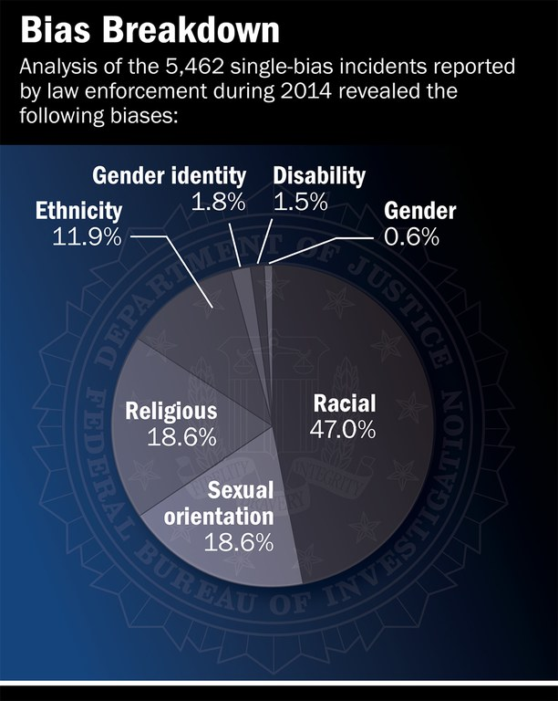

FBI Hate Crime Incidents 2014

In fact, in just about any kind of human rights violation, one can find religious beliefs as the basis. The moral light of society is not so bright.

Conversely, a self-regulating child has an understanding the rules and reasons behind them and the consequences of breaking them, both naturalistic (flowing from the action) and legal (man made). Not being dependent on an authority figure means that the child, as stated in the United Nations Convention on Children’s Rights, Article 14: The State shall respect the child’s right to freedom of thought, conscience and religion [in an age appropriate manner] is therefore free to form their own beliefs, hopefully informed by facts and reason. Interpreting this UN Article, I see the role of the secular parent as guiding the child in becoming an autonomous being. The child must eventually select their profession, their mate, their political affiliation, and religion because primarily they (not the parents) must be comfortable with those choices as they must live with them day to day and answer for them.

Rewards & Punishments to be Good

"Christianity has such a contemptible opinion of human nature that it does not believe a man can tell the truth unless frightened by a belief in God. No lower opinion of the human race has ever been expressed.” -- Robert Green Ingersoll

God appears to be a Behaviorist. In this theory, “behavior is the result of stimulus – response. All behavior is learnt from the environment. We learn new behavior through classical or operant conditioning (rewards and punishments for a given behavior). There is little difference between the learning that takes place in humans and that in other animals. People have no free will – a person’s environment determines their behavior” (an environmental stimulus will produce a certain response) McLeod.

That is how God gets us to do the right thing and avoid wrong behavior, just like we train animals. There is little free will here as you will be punished if you do not comply. Conversely, secular people strive to do the right thing because it is the right thing to do (do not consider rewards other than the natural consequences of an act).
Toddlers are first introduced to moral (and other) behaviour by what is punished or prohibited. Religion makes a mistake by stopping at this stage by using the threat of hell or the reward of heaven as the main motivators of good behaviour into adulthood. The trouble with this type of incentive system is that as soon as the reward or punishment is removed the person reverts to more convenient behaviour. Again, we want self-regulation where appropriate behaviour is internalized.
Indoctrination

Indoctrination is what Communist states do to keep their people under control. The same is true for religion and it depends on a helpless person depending on an authority figure that is supposed to be trusted to tell them the truth. Psychologist calls what ensues a “belief bias,” where, “people will tend to accept any and all conclusions that fit in with their systems of belief, without challenge or any deep consideration of what they are actually agreeing with. The reverse is also true, and people will tend to reject assertions that do not fit in with their belief systems, even though these statements may be perfectly logical and arguably possible” (Changing Minds).

Indoctrination is the equivalent of rote learning where the student memorizes and regurgitates information, but has as very shallow understanding of it. This sets them up to be easily deceived. Secular parents, on the other hand, stress both open access to information and critical thinking. A secular child can tell you why they believe or do not believe in something and would only change that position with convincing evidence—not because an authority figure says so.
Here is the definition of indoctrination: “To teach (someone) to fully accept the ideas, opinions, and beliefs of a particular group and to not consider other ideas, opinions, and beliefs.” Hence, indoctrination produces ‘closed systems.’ The vacuum of the unknown about other belief systems (as they are automatically viewed as false) is filled with fear and fear many times can turn into hate. Many of mankind’s wars have revolved around religious disputes. Robert Ingersoll correctly observed, “Strange but true, those who have loved God most have loved men least.” The Bible was on the mark here in stating, “and you shall know them by their fruits” (Matthew 7:16).

Proper secular parenting does not impose any of the following on their children:

- What they should study in university
- What career they should have
- Who they should date or marry
- Political party membership
- How to dress or groom (style choices)
- Dietary regimens (vegetarian, etc.)
- Sexual orientation
- Religion

Imposition in any of these areas is equivalent to seeing children as extensions of their parents—not autonomous beings. It is a violation of their rights under the UN Article 14, as previously mentioned.

Is God the Model to Follow?

Ephesians 5:1 exhorts us to, “Imitate God…in everything you do, because you are his dear children.”
Now read the University of Oxford's Professor for Public Understanding of Science, Richard Dawkin’s description of God: “The God of the Old Testament is arguably the most unpleasant character in all fiction: jealous and proud of it; a petty, unjust, unforgiving control-freak; a vindictive, bloodthirsty ethnic cleanser; a misogynistic, homophobic, racist, infanticidal, genocidal, filicidal, pestilential, megalomaniacal, sadomasochistic, capriciously malevolent bully.” Every one of those charges is grounded in biblical passages describing God’s behavior. So is this the God to be imitated?

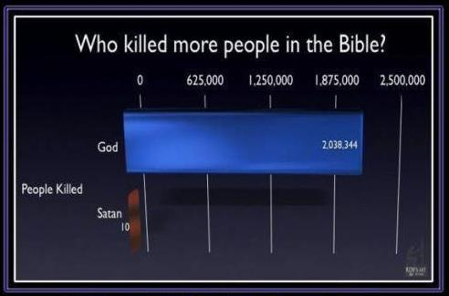

Closely related, Researcher Professor Robert Altemeyer has studied personality traits classified as “social dominators,” or in plain language, authoritarian leaders. Here is what psychological testing of them reveals: “They’re typically men; they are dominating; they oppose equality [i.e., anti-democratic]; they are desirous of personal power; they are amoral, intimidating and bullying, faintly hedonistic, vengeful, pitiless, exploitive, manipulative, and dishonest; they will cheat to win; they are highly prejudiced (racist, sexist, and/or homophobic), mean-spirited, militant, and nationalistic; they tell others what they want to hear, take advantage of “suckers,” and specialize in creating false images to sell themselves” (Verdict). This came from an article written by John Dean (Nixon’s legal counsel) who also wrote book on the topic called Conservatives without Conscience.

Does that description remind you of anyone running for President in America? The Republican (party of God) field of candidates are constantly lying and using deceptive practices, yet profess their Christianity and are focused on attracting the evangelical and other religious voters. What is sickening is that these candidates are being endorsed by Christian ministers like Pat Robertson, who has a massive following, and who should know better. Examine the following graphic for Donald Trump. Click here to see the other candidates. There is a direct correlation between their outward religiosity and lying.

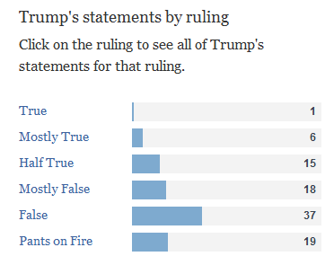
Politifact Fact-Checker Service

So it appears that many Christians have lost their ability to discern right from wrong, yet accuse atheists of having this problem! If the educated leaders have trouble behaving, what about the man in the street? We turn to that now.

Remember the outcomes that research shows are the products of religious upbringing (for the average person) discussed at the beginning of this paper: adults who are, more vengeful, more nationalistic, more militaristic, more authoritarian, and more intolerant? Children from religious families are less kind and more punitive than those from non-religious households. This completes the trifecta, a heavy overlap of traits at three levels: the OT God, conservative political leadership, and the average believer. Merely coincidence?

It appears that many believers are following the Old Testament God in lock step, but you say they are supposed to follow that other God (New Testament) who is loving, merciful, and patient. Well the NT God is also wrathful and promises consequences for bad behavior. No matter which Testament you read, God has an authoritarian, negative and punitive side. But, Matthew 5:48, admonishes us, “Be perfect…as your heavenly Father is perfect.” First, no human can be perfect and striving for it is an illusion that can cause psychological damage when it becomes an obsession. Maybe “excellence” is the answer instead of perfection, as outlined in the following insert.

Second, the question remains: be a perfect what? A perfect model of the OT God?

Of course, if you argue that the God of the OT is not the same as the God of the NT, now you have to explain why God changed a lot of His behavior. Good luck.

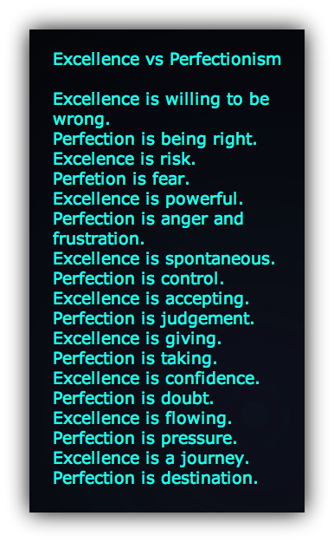
Source: Your Inner Critic.

Compliance to a “Plan” for your Life

Yes, God has a plan for your life. You are not in charge of your life, He is. In fact, it was all written down before you were born: “You saw me before I was born. Every day of my life was recorded in your book. Every moment was laid out before a single day had passed,” Psalm 139:16.

So the game plan for believers is to uncover the plan because they cannot see or read it in “the book.” This causes endless second guessing and constantly wondering if you are “right with God,” which is stress inducing. Of course, the other approach is to act very much like an atheist and just do what your heart tells you is right.

Given that every day of your life is already recorded or fixed, where is this free will that He supposedly gives us? Under this deterministic system free will can only be an illusion. No matter what we do we cannot escape our fate. If we are bound for hell that is it. How do we know this? Revelation 13:8. informs us: “And all the people who belong to this world worshiped the beast. They are the ones whose names were not written in the Book of Life before the world was made--the Book that belongs to the Lamb who was slaughtered.”

In other words, before Creation, God decided who was going to heaven or hell to suffer for eternity. Besides being deterministic, it is incredibly cruel to create a soul that you already know is bound for hell. This mean spiritedness is unconsciously picked up by believers as they strive to act like God. The psychology is anything but love.

The true apologist will tell us, yes, God knows all things, and he knows you are going to hell, but in all His mercy…He wants YOU to know why you are going there! This teaches children that there are some people so wicked that there is no other place for them. It is attack on our humanity, where everyone makes mistakes, but that there are things so terrible that one can never be forgiven for them and require eternal suffering. This harsh treatment of humans by God is not lost on believers.

Faith over Facts

President Obama recently remarking on the Republican primary campaign, noted that not one candidate believes in global warming (caused by human activity), yet all have university educations. There is now overwhelming scientific evidence for it, yet the fundamentalists refuse to entertain it.

If it is not in the bible or contradicts it, then it is not true, seems to be the mantra. We are teaching our kids to put cave-dwelling, goat-herding, illiterate opinions of 2,000 years ago above the latest scientific facts. Our grandchildren and their decedents need to live on this planet in a healthy environment. Of course, Jesus is “coming soon” so we really don’t need to take care of the environment, as He is destroying the world anyways, is the logic.

Here are a few of the faith-vs-fact conflicts:

- Evolution is ‘just a theory’ (gravity is just a theory, too)
- The world was created in seven days vs. Big Bang
- People are not part of the animal kingdom
- Global Warming is a hoax
- Homosexuality is a choice
- Secular people cannot be moral
- Prayer works
- God is in control (of only good things that happen or everything?)
- God can only do good things
- Beating a child teaches discipline
- Miracles are true
- The USA was founded on Christian principles
- The earth is the centre of the universe
- “Historical” events (Jews in Egypt, plagues, parting of the Red Sea, Roman Census, killing of first borns, the Great Flood…)
- Dinosaurs and men co-existed
- The afterlife exists
- (totally) free will
- Ban on gun control research by Congress
- Carbon dating is flawed
- Teen abstinence pledges work
- The death penalty deters crime
- Noah’s ark at 450 feet long could hold and feed all the 8.7 million species of known animals (even today we don’t know about 85% of all animal species)
- Genocide (see #5) is OK if God says to massacre others including children
- Worst of all they will not say “I don’t know” when they don’t know something

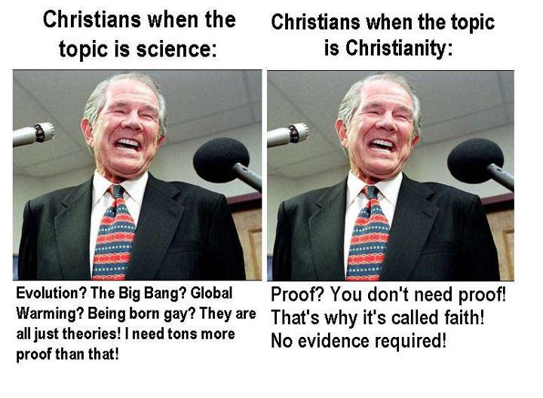

Why are we teaching children to believe not only in fairy tales but dangerous notions that can harm people if not addressed? What happened to “the truth shall set you free?” Religion apparently shows a serious disrespect for truth masquerading as God’s super-truth. Ignorance is the greatest enemy of mankind. Aren’t we done with the Dark Ages yet?

Can Promote Selfishness & Dependency

I can’t help but observe that many people who call themselves religious are incredibly selfish or materialistic. Instead of getting out there and helping their fellow man, they are in church prayer services ‘getting right with God’ in order to influence Him to release an abundance of material blessings. This is now popularly known as the Prosperity Gospel: end your suffering now, get your good health back, get rid of your debts, enjoy financial riches now. Me-me-me. Several evangelical preachers who personify this are Joel Osteen, Benny Hinn, and Joyce Meyer along with an outright thief, Mike Murdock, who demands ‘seed money’ to prime God’s pumps. It is nothing short of biblically sanctioned greed.

This philosophy rolls over into politics where it is the (God fearing) conservatives who want to cut back on social programs so their taxes will go down. They decry the godless liberals who want to help the disenfranchised in society.

Another area of selfishness is eternal life and making sure that you are getting there. One’s agenda becomes getting saved, not by serving others, but by trying to appease God. The formula is to just stay out of trouble and believe in Jesus and you are heaven bound. The commandment to love is very narrowly exercised to include relatives and some friends.

Turning to dependency, the whole idea of parenting is to promote an independently functioning human being. Religious upbringing starts with the belief that I am nothing without God. So I pray to Him to guide me (so I do not have to use the brain He gave me?). God never fails. So everything will be OK as long as I pray. This is good up until the point where life interrupts this fairytale. One of the underlying issues here is what percent of any outcome is due to your effort and what percent is God’s? If I pray before I take a test, is God actually whispering the answers in my ear or giving me some other type of special advantage? Therefore, I do not need to study as hard as an atheist who must pass the test on their own? At this point one can go down the slippery slope of dependency. Prayer can be a cop-out for personal action: “It’s in God’s hands now.” Secular kids roll up their sleeves with the attitude: if I don’t get involved, nothing will fix itself.

The same is true with faith healers. If I acquire a disease (like by not living a healthy life style) God will pull me out (if I have enough faith). Warning: God cannot heal amputees. Reliance on God can create an unhealthy dependence. Secular kids know they are responsible for their health—not a doctor, not God.

Conclusion

Religious upbringing--we are understanding more and more--violates much of what research now shows to be the healthy way to raise human children of good character. It misunderstands basic human nature and psychology thinking that devils cause us to misbehave instead of hormones or our amygdala (primitive emotional brain stem). It does not make a distinction between humans and other animals in terms of learning, control, or discipline. It employs way too much fear, shame, and guilt and not enough love. It relies on bribing people to be good with the reward of heaven. It does not help us to answer what is right and wrong beyond that on which we all agree already (lying, cheating, stealing, raping, killing, etc.). It relies more on (unthinking) rules than instilling responsibility and, as such, does not strengthen moral reasoning. It is anti-truth from its use of indoctrination of children to the faith-vs.-facts conflicts where evidence (i.e., truth) is irrelevant. It models behavior on a dictatorial God figure, who will cause suffering and punishment for those who do not follow His plan, thus denying anyone true free will. It can promote both selfishness (e.g., chasing prosperity, or desiring to be ‘Blessed and Highly Favored’) and dependency.

Therefore, it in not surprising, that in many cases, a religious upbringing creates adults who are very much like right-wing Republicans: authoritative, nationalistic, militaristic, dogmatic, vengeful, punitive, intolerant, and mean spirited. For the ones that do not turn out that way, the parents probably intuitively steered clear of the more extreme aspects of religious practices, and therefore, acted as de facto secular parents.

I predict that future research will eventually establish causal linkages between religious parenting practices and the type of child that is molded. Many of these practices will one day be called for what they really are: child abuse. In today’s world we need less tribalism and more openness, understanding and empathy and secular parenting--done correctly--appears to hold this promise.



